EE 5356_ DIGITAL IMAGE PROCESSING

INVERSE & WIENER FILTERING

NAME: PAVAI ARCHIMEDES

ST ID: 1001233996

PROCEDURE:

1) Read an image (any size up to 512x512).

2) Calculate the three different H(u,v) with k=0.0025, 0.001 and 0.00025.

3) Calculate G(u,v) with H(u,v) obtained in 2), and show the three different blurred images.

4) Take the inverse filtering and Wiener filtering for each G(u,v).

5) Show the restored images with ratios N/H, where N and H are power spectra of additive noise ( m n , ) η and h(m, n) respectively.

Note: N, H are in 2D-DFT domain.

PROGRAM:

clc;

clear all;

close all;

ep = 0.001;

I = imread('C:\Users\PAVAI ARCHIMEDES\Desktop\boat512.gif');

dimension = size(I);

figure(1);

imshow(I);

title('original image');

F = fft2(I);

F1= fftshift(F);

N1 = 512;

H1 = zeros(512);

H2 = zeros(512);

H3 = zeros(512);

for u = 1:N1

for v = 1:N1

H1(u,v) = exp(-0.0025*((u-N1/2)^2+(v-N1/2)^2)^(5/6));

end

end

N1 = 512;

for u = 1:N1

for v = 1:N1

H2(u,v) = exp(-0.001*((u-N1/2)^2+(v-N1/2)^2)^(5/6));

end

end

N1 = 512;

for u = 1:N1

for v = 1:N1

H3(u,v) = exp(-0.00025*((u-N1/2)^2+(v-N1/2)^2)^(5/6));

end

end

N11 = randn(512,512);

N1_DFT = fft2(N11);

H1_DFT = fft2(H1);

H2_DFT = fft2(H2);

H3_DFT = fft2(H3);

G1 = F1.*H1+N11;

deg_im1 = ifft2(ifftshift(G1));

G2 = F1.*H2+N11;

deg_im2 = ifft2(ifftshift(G2));

G3 = F1.*H3+N11;

deg_im3 = ifft2(ifftshift(G3));

figure(2);

subplot(1,3,1);

imshow(uint8(deg_im1));

spll=sprintf('deg img k = 0.0025');

title(spll);

subplot(1,3,2);

imshow(uint8(deg_im2));

spll=sprintf('deg img k = 0.001');

title(spll);

subplot(1,3,3);

imshow(uint8(deg_im3));

spll=sprintf('deg img k = 0.00025');

title(spll);

for u = 1:N1

for v = 1:N1

if(H1(u,v) < ep)

K33(u,v) = 0;

else

K33(u,v) = 1/H1(u,v);

end

end

end

for u = 1:N1

for v = 1:N1

if(H2(u,v) < ep)

K333(u,v) = 0;

else

K333(u,v) = 1/H2(u,v);

end

end

end

for u = 1:N1

for v = 1:N1

if(H3(u,v) < ep)

K3333(u,v) = 0;

else

K3333(u,v) = 1/H3(u,v);

end

end

end

F11 = G1.*K33;

F12 = G2.*K333;

F13 = G3.*K3333;

re_im1 = ifft2(ifftshift(F11));

re_im2 = ifft2(ifftshift(F12));

re_im3 = ifft2(ifftshift(F13));

figure(3);

subplot(1,3,1);

imshow(uint8(re_im1));

spll=sprintf('Res img k = 0.0025');

title(spll);

subplot(1,3,2);

imshow(uint8(re_im2));

spll=sprintf('Res img k = 0.001');

title(spll);

subplot(1,3,3);

imshow(uint8(re_im3));

spll=sprintf('Res img k = 0.00025');

title(spll);

ratio1=sum(sum(abs(N1_DFT)))/sum(sum(abs(H1_DFT)));

ratio2=sum(sum(abs(N1_DFT)))/sum(sum(abs(H2_DFT)));

ratio3=sum(sum(abs(N1_DFT)))/sum(sum(abs(H3_DFT)));

disp('ratio1');

disp(ratio1);

disp('ratio2');

disp(ratio2);

disp('ratio3');

disp(ratio3);

zzz = zeros(512);

zzz = abs(fftshift(ifft2(fft2(I).*conj(fft2(I)))))./(512^2);

Rnn = zeros(512);

Rnn = abs(fftshift(ifft2(fft2(N11).*conj(fft2(N11)))))./(512^2);

Suu = fftshift(fft2(zzz));

Sxx = fftshift(fft2(Rnn));

W1 = conj(H1).*Suu./((abs(H1).^2).*Suu+Sxx);

W2 = conj(H2).*Suu./((abs(H2).^2).*Suu+Sxx);

W3 = conj(H3).*Suu./((abs(H3).^2).*Suu+Sxx);

F11 = G1.*W1;

F12 = G2.*W2;

F13 = G3.*W3;

re_im1 = ifft2(ifftshift(F11));

re_im2 = ifft2(ifftshift(F12));

re_im3 = ifft2(ifftshift(F13));

figure(4);

subplot(1,3,1);

imshow(uint8(re_im1));

spll=sprintf('Res img for Wi = 0.0025');

title(spll);

subplot(1,3,2);

imshow(uint8(re_im2));

spll=sprintf('Res img for wi= 0.001');

title(spll);

subplot(1,3,3);

imshow(uint8(re_im3));

spll=sprintf('Res img for wi= 0.00025');

title(spll);

ratiow1=sum(sum(abs(N1_DFT)))/sum(sum(abs(H1_DFT)));

ratiow2=sum(sum(abs(N1_DFT)))/sum(sum(abs(H2_DFT)));

ratiow3=sum(sum(abs(N1_DFT)))/sum(sum(abs(H3_DFT)));

disp('ratiow_1');

disp(ratiow1);

disp('ratiow_2');

disp(ratiow2);

disp('ratiow_3');

disp(ratiow3);

RESULTS:

ratio1

453.6736

ratio2

453.6736

ratio3

441.5313

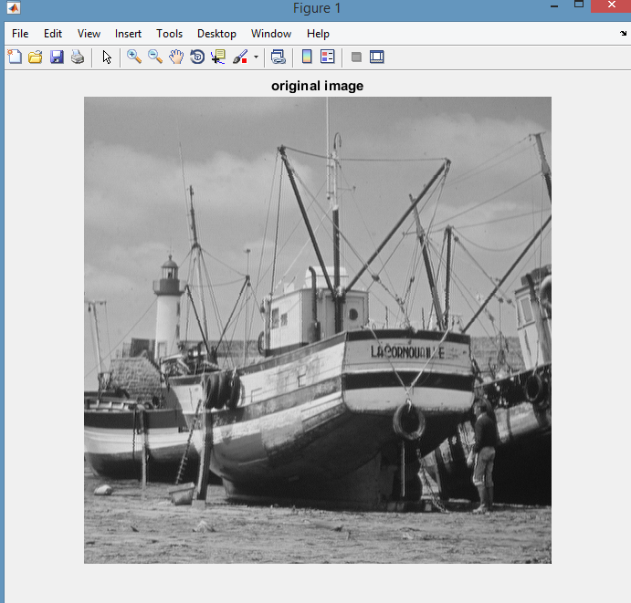

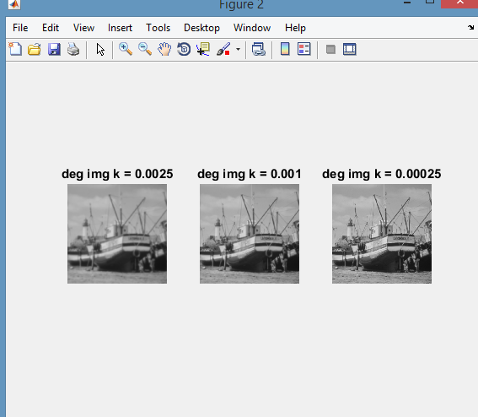

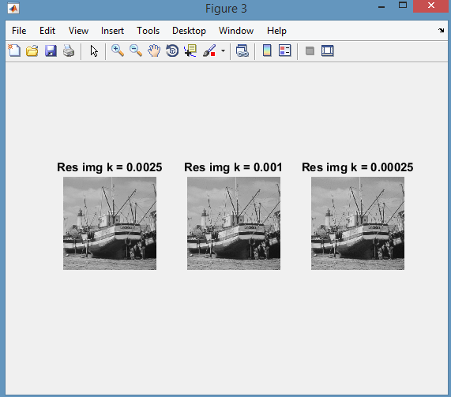

ratiow_1

453.6736

ratiow_2

453.6736

ratiow_3

441.5313

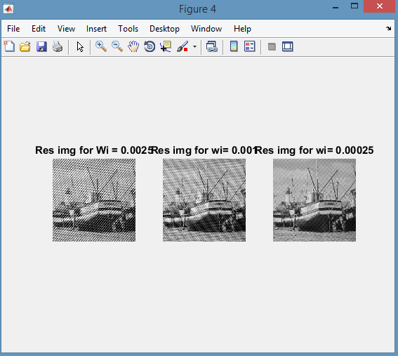

CONCLUSION:

All the steps mentioned in the procedure has been performed and various results are observed.